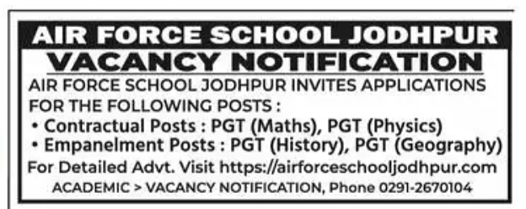

Please note that the last date for submission the application form is 12 February 2025 and for further details, please refer to the Detailed Advertisement available on the school's website.